Snowy Owl Hotel 
The city of Krasnoyarsk

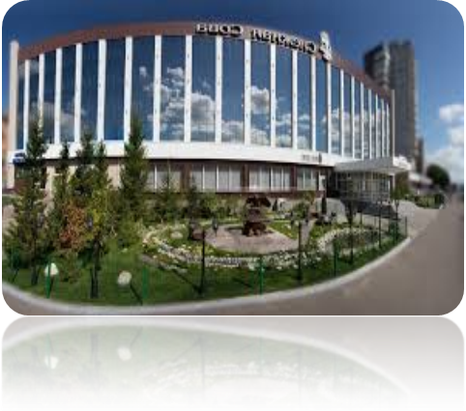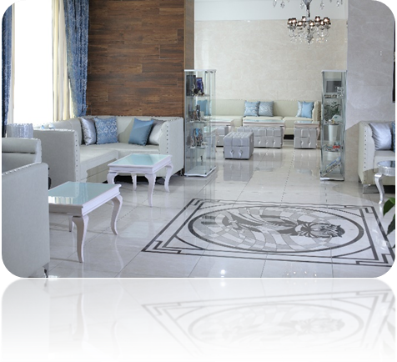
The Snowy Owl Hotel offers to consider the possibility of cooperation on accommodation in Krasnoyarsk. It is a 3-star hotel. Convenient location allows you to get to any part of the city within 15 minutes.
The total number of rooms of the hotel is 110 rooms of 3 categories: “standard”, “comfort”, “luxury”. For a comfortable stay of guests in each room there is: air conditioning, individual ventilation, mini fridge, tea accessories, individual items in the bathroom, bathrobe, slippers. Free WI-FI throughout the hotel.
We bring to your attention a commercial offer for group accommodation.

Hotel location

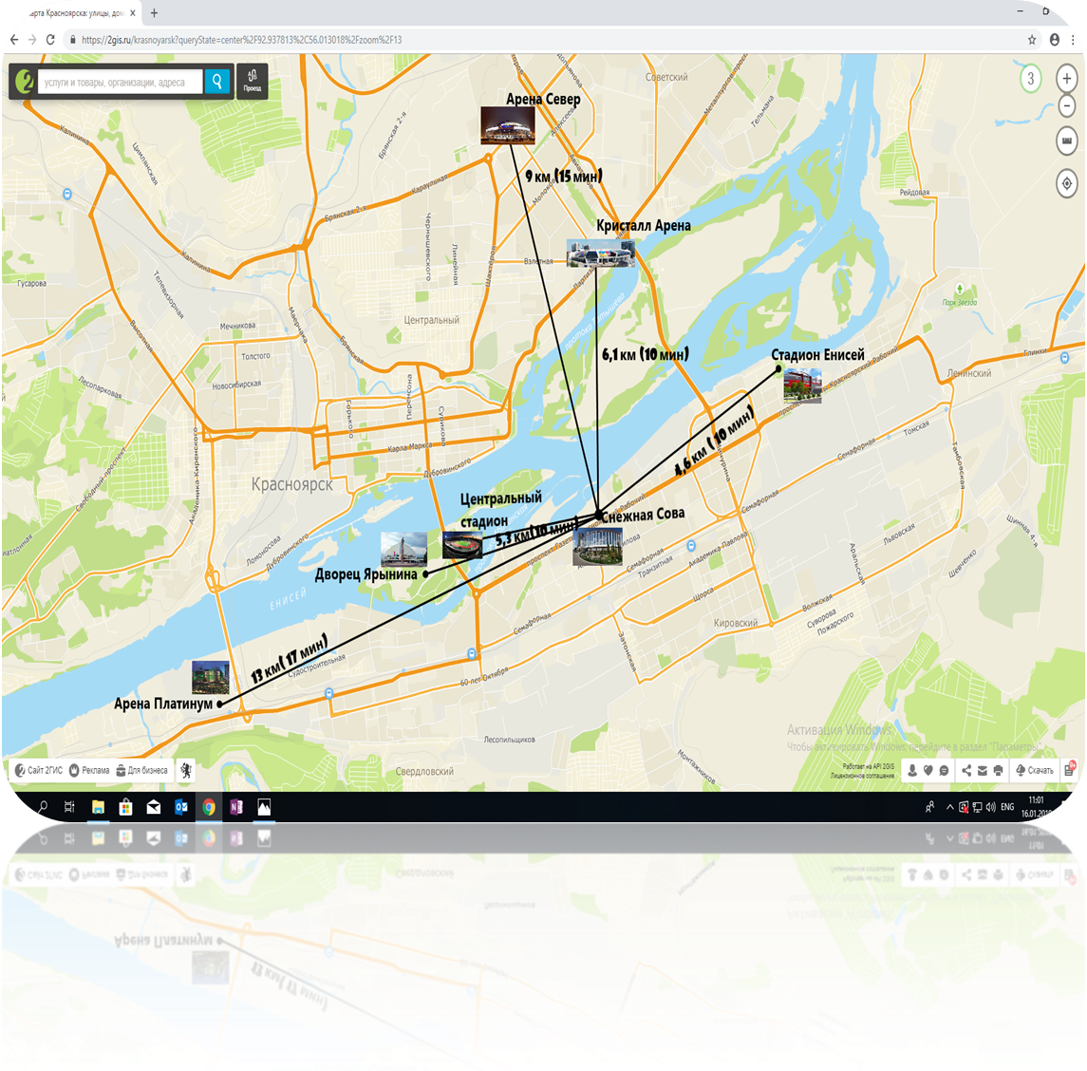

Standard single room

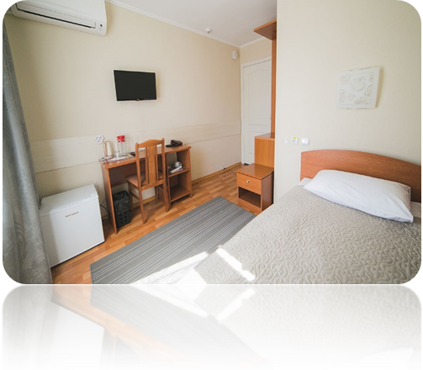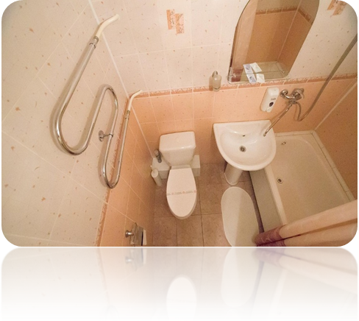
• bed 0.9 × 2 m
• separate workplace
• plasma TV
• phone
• fridge
• electric kettle and dish set
• Wi-Fi

The cost is 1 000 rubles

Standard double room with two beds
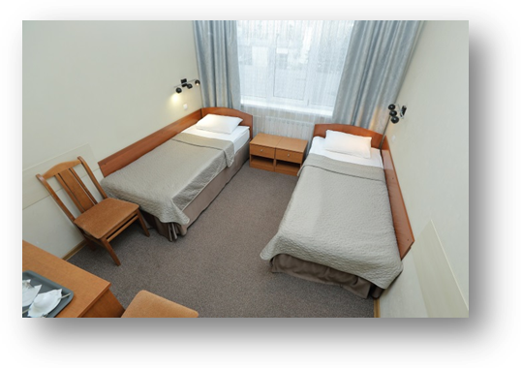
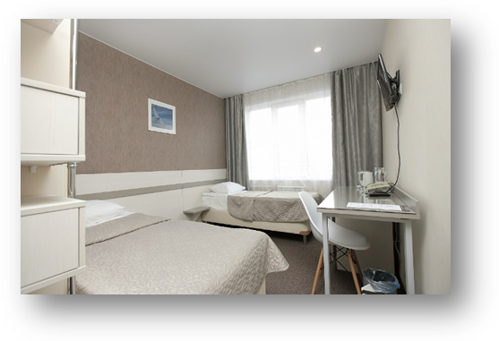

Two single beds 0.9 × 2 m; workplace, TV, air conditioning, refrigerator. We provide free Wi-Fi for hotel guests, so that you always have free Internet access.
In each room at your service:

• bed 0.9 × 2 m
• separate workplace
• plasma TV
• phone
• fridge
• electric kettle and dish set
• Wi-Fi

The cost of the room is 1 600 rubles
(800 rubles per person)

Superior single room
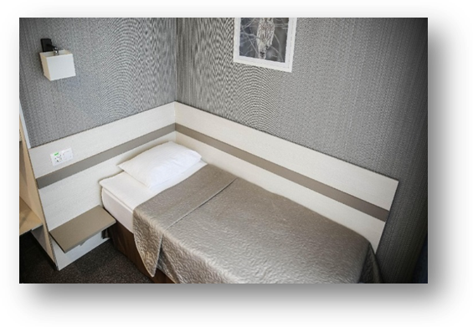
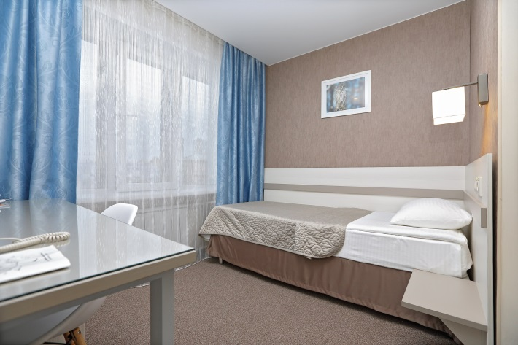
The bed is 0.9 * 2 m in size, has a separate workplace, TV, telephone, refrigerator, kettle, dish set, a bathroom with toiletries, air conditioning.
Room for one person, equipped with everything necessary for work and leisure.
• Wi-Fi in guest areas
• Phone
• Guest computer
• Cable TV
• Ironing room

The cost of the room is 1 200 rubles

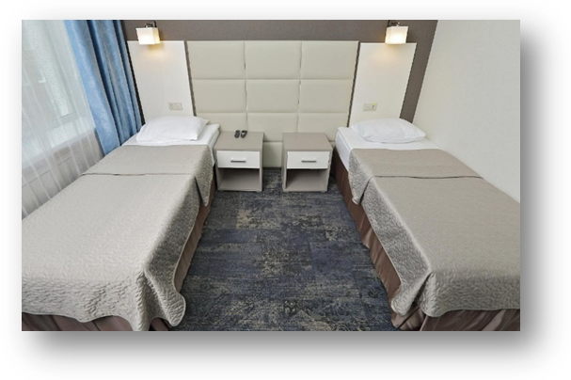
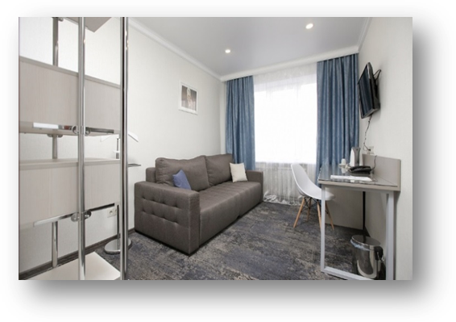
Conform two rooms apartment:
two beds + sofa + extra bed
(accommodation for three and four people) 

It has everything you need to create a feeling of comfort and homey home: in the living room there is a comfortable sofa and a flat-screen TV for relaxing, in the bedroom there are 2 beds 0.9 × 2 m and a separate working area. We provide guests with free Wi-Fi.
In each room at your service:

• two single beds 0.9 × 2 m
• soft furniture
• coffee table
• separate workplace
• plasma TV
• phone
• fridge
• electric kettle and dish set
• Wi-Fi

The cost of the room is 800 rubles per person

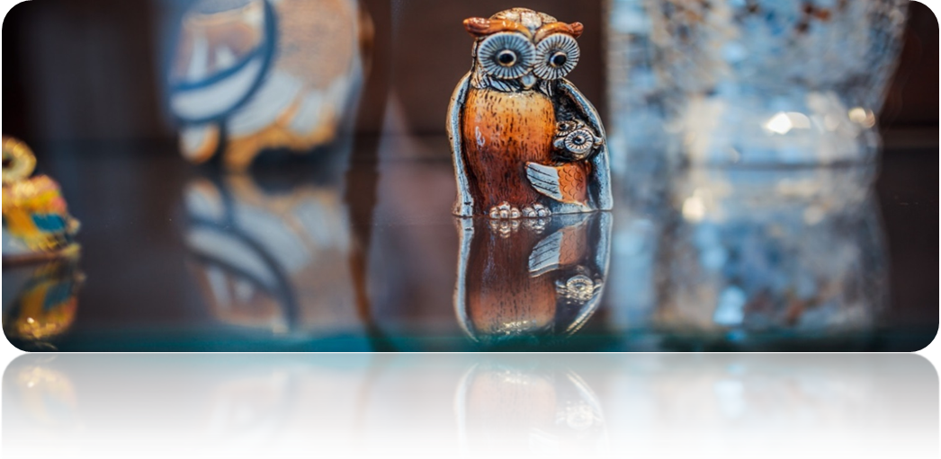
Compliments from the hotel

Compliments from the hotel:
- use of the gym
- free Wi-Fi throughout the hotel
-free meeting room provision
Additional paid hotel services:
- phyto barrel, massage services, spa-complex
- organization of excursions to the sights of the city
- souvenir shop
- laundry service
- transfer

Meal
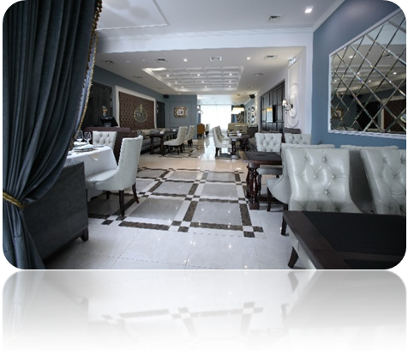
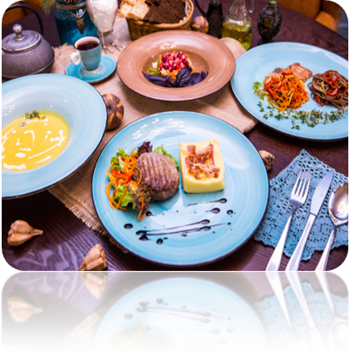
- Breakfast – 400 rubles (open buffet).
- Set lunch – 350 rubles.
- Set lunch – from 350 rubles.
- Set dinner – from 350 rubles.
- It is possible to calculate an individual menu on request.

We will be happy to answer all your questions.
Please read more about us on our website
www.snowyowlhotel.ru
Senior administrator
Tikhonovich Ksenia
Tel. (391) 201-10-00, sale@snowyowlhotel.ru

